**DAILY ONLINE ACTIVITIES SUMMARY**

|  |  |  |  |  |  |
| --- | --- | --- | --- | --- | --- |
| **Date:** | **6-06-2020** | | **Name:** | **Shanbhag Atish Manoj** | |
| **Sem & Sec** | **6th - B** | | **USN:** | **4AL17CS085** | |
| **Online Test Summary** | | | | | |
| **Subject** | **PYTHON APPLICATION PROGRAMMING** | | | | |
| **Max. Marks** | **30** | **Score** | | **29** | |
| **Certification Course Summary** | | | | | |
| **Course** | **Algorithmic Toolbox** | | | | |
| **Certificate Provider** | **Coursera** | **Duration** | | | **5 Weeks** |
| **Coding Challenges** | | | | | |
|  | | | | | |
| **Status: executed** | | | | | |
| **Uploaded the report in GitHub** | | **Yes** | | | |
| **If yes Repository name** | | <https://github.com/atish-shanbhag/Updates> | | | |
| **Uploaded the report in slack** | | **Yes** | | | |

PAP IA -3

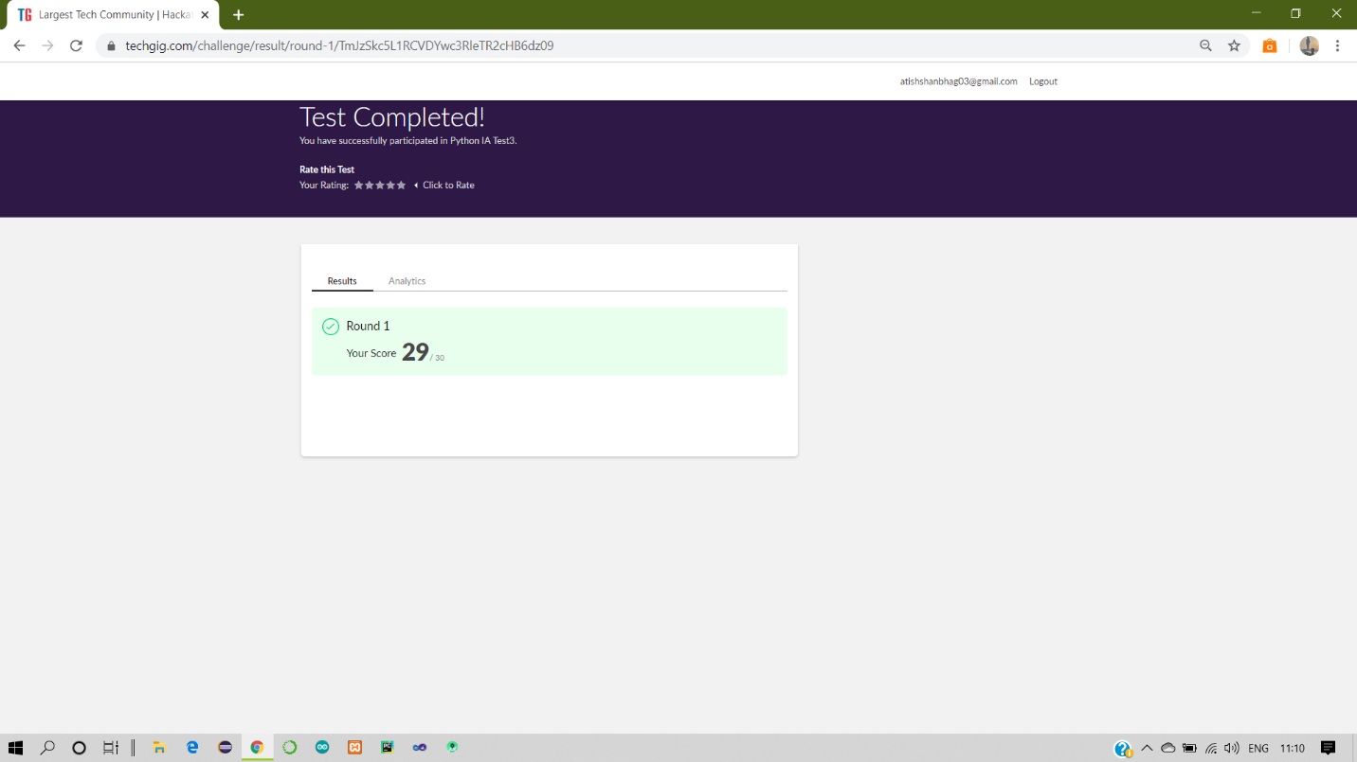

Certification Course Details:

Report

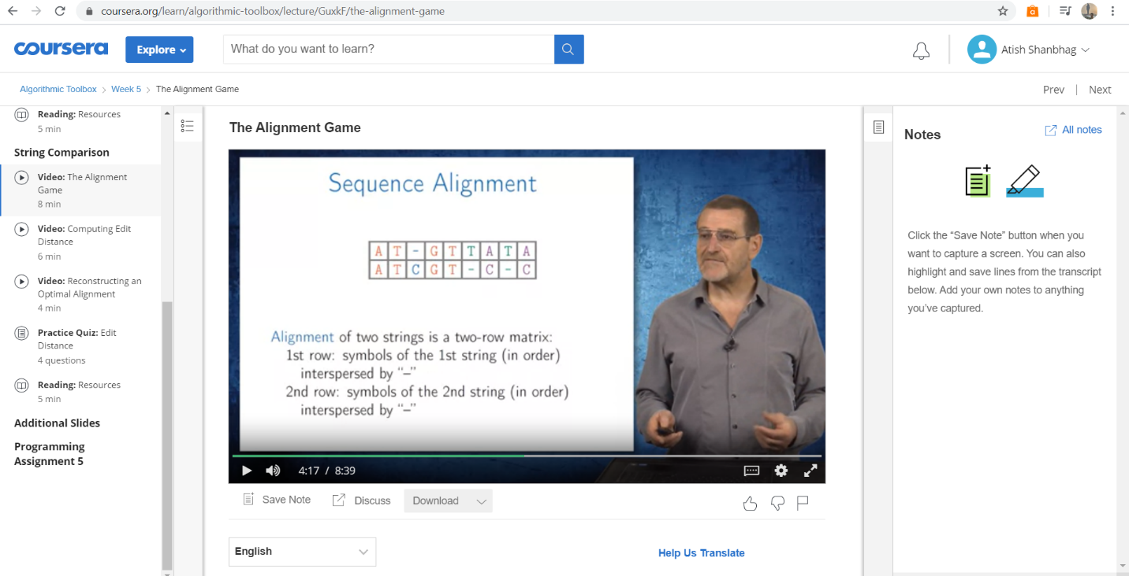

In today online certification session, I have studied topics related to string comparison in dynamic programming and implementation with various worked examples and assignments.

Coding Challenges Details:

The below GitHub link for details

<https://github.com/atish-shanbhag/Updates>

P-1

**Python program count string from list**

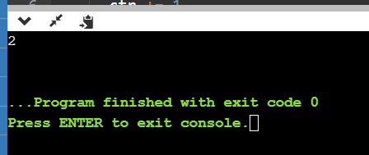

**P-2**

**Python program to implement CRC**

